**Reduce Power Consumption of Transmitter in Optical Communication**

**Mayank Garg , Shivangi , Veenu Gupta**

**Abstract:** – Now-a-days, Optical Communication are used everywhere for very high-speed data communication. In Optical Communication, we transmit digital data in form of light. In digital, there are two level of logic 0’s and 1’s which is represented by 0V and 5V respectively. In Optical Communication, we represent logic 1 by intensity of light or number of photons and logic 0 is represented by no light or no photon. To transmit a 5V level or number of photons from one end to another end, system requires some amount of power which is more in comparison to transmit a 0v level or no light. Here, we have made an algorithm to transmit sequence of binary stream in which if number of set bits or logic 1 is more than 0’s than we will invert that sequence of binary and generate modulating carrier pulse only when bit is 1.

**Introduction: -** In Optical Communication, we transmit sequence of bits of different length. In every sequence, probability of 0’s and 1’s is also different. Each bit in Binary sequence is either ‘0’ or ‘1’ which has different representation. Similarly, in Optical we represent it in the form of photons. If photons of particular wavelength are present that means logic is ‘1’ else it is logic ‘0’. But here we noticed that to represent logic ‘1’, we need more power. Basically, we mean that if probability of logic ‘1’ in any sequence is more than logic ‘0’ then the transmitter wants more power to transmit. So, we design an algorithm to reduce power which is consumed by transmitter to transmit that sequence in which number of 1’s is more.

In our algorithm, firstly, in the transmitter block, we read any block of data in binary form and create its frame where the frame size is 24 bits/frame. In starting of frame, we add an additional bit which is used at receiver to identify that the new frame is started which is by default set as logic ‘0’. The next step is to count the number of logic ‘1’ bits of every frame and if logic ‘1’ bits is more than half size of frame rate then invert the whole frame including the starting bit which we have added in the start of frame and then we get a new sequence of ‘0’ and ‘1’ in the transmitter block. If bits in a frame is less than 24 and count of 1’s is also less than half of frame then we will transmit that frame normally means without inverting.

Now, at the Receiver Block, if starting bit of frame is set or logic ‘1’ then invert rest of the bits of frame and send it to the decoder block, else if starting bit is logic ’0’ then directly send it to the decoder block to decode and convert back into the form of worthy information or original data which is transmit by the transmitter.

# Pseudocode for this algorithm: -

## Algorithm of Transmitter: -

% At transmitter side

%Read data in form of Binary stream

a = fread('file name')';

%sample Binary stream into frames at 24 bits/frame and add a starting bit in each frame

while a!= empty()

b = zeros(1,25); % Create a buffer of size 25 bits

for i = 1:24

if a[i] == null % If bits is less than frame size

transmitter = a;

break;

end

if a[i] == 1

count++; % Count 1's in each frame

end

end

% if count of 1's in each frame is more than 50% of frame size then

% invert signal and put 1 at starting bit else 0.

if count > 12

for i = 2:25

b[i] != a[i]; %store inverted bits of 'a' in buffer

end

b[0] = 1; % set the starting bit

else

b = a; % Store bits of 'a' in buffer

end

transmitter = b; % Transmit frame b

end

## Algorithm of Receiver: -

% At Receiver side

% Binary stream from Receiver block

% if starting bit is 1 then invert whole frame bits else nothing to do

while b != null % b is buffer which store frame bits

if size(b) < frame size % If bits is less than frame size

decoder = b;

break;

end

if b[1] == 1 % If Starting bit is 1

for i=2:25

frame[i] != b[i];

end

else

for i=2:25

frame[i] = b[i];

end

end

% put receiving bits to the decoder block

decoder = frame; %decode frame bits

b = 0; %initialize buffer

end;

## Flowchart of the Designed Algorithm: -

Read binary file

Put the starting bit ‘0’ and frame bits to the transmitter

If bits >= 24

No

Yes

Frame rate=24

Starting bit=0

Count = 0

If bit is equal to ‘1’

Yes

Count+1

Yes

No

Frame - 1

No Yes

If count > frame rate / 2

If frame is equal to 0

Yes No Yes

Put the starting bit and frame bits to the transmitter

Inverting Frame bits and starting bit

Fiber Optics

Fiber Optics

If bits >= 24

Receiver

No

Yes

Frame rate=24

If starting bit is equal to 1

Yes

Invert Frame bit

No

Frame rate-1

If Frame rate is equal to 0

Yes

No

Decoder

Output

We design a Direct Transmitter Circuit in Opti Wave Software in which we use a laser which is radiating 20dB power for any type of binary stream. So, power consumption for Direct Transmitter is same 19.794dB for different sequence of logic 0’s and 1’s transmits through the optical cable as shown in the figure 1.

# Direct Transmitter Circuit: -

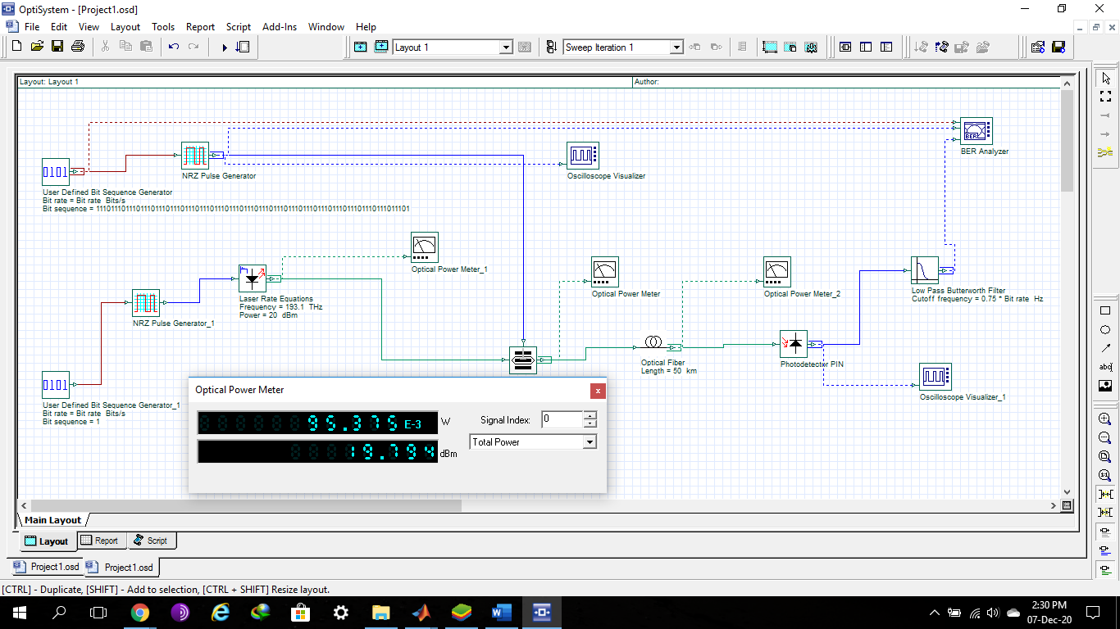

Fig. no. 1

# Inverted Transmitter Circuit: -

Inverted Transmitter circuit, which will first invert the whole sequence of binary stream, switch the laser according to binary stream and after that transmits to the optical cable and observe power consumption of laser for Inverted Transmitter as shown in figure 2.

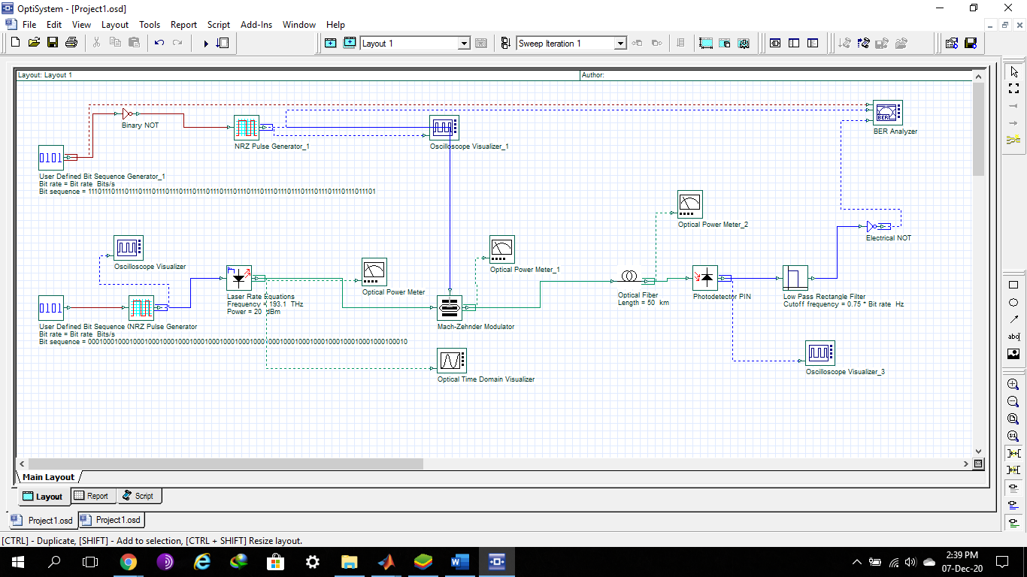

Fig. No.2

First, we transmit a binary stream of 1’s up to 10^6 bits through both Direct Transmitter and Inverted Transmitter Observe power consumption of laser respectively.

Power Consumption of Laser of Direct Transmitter is shown in the Figure number 3.

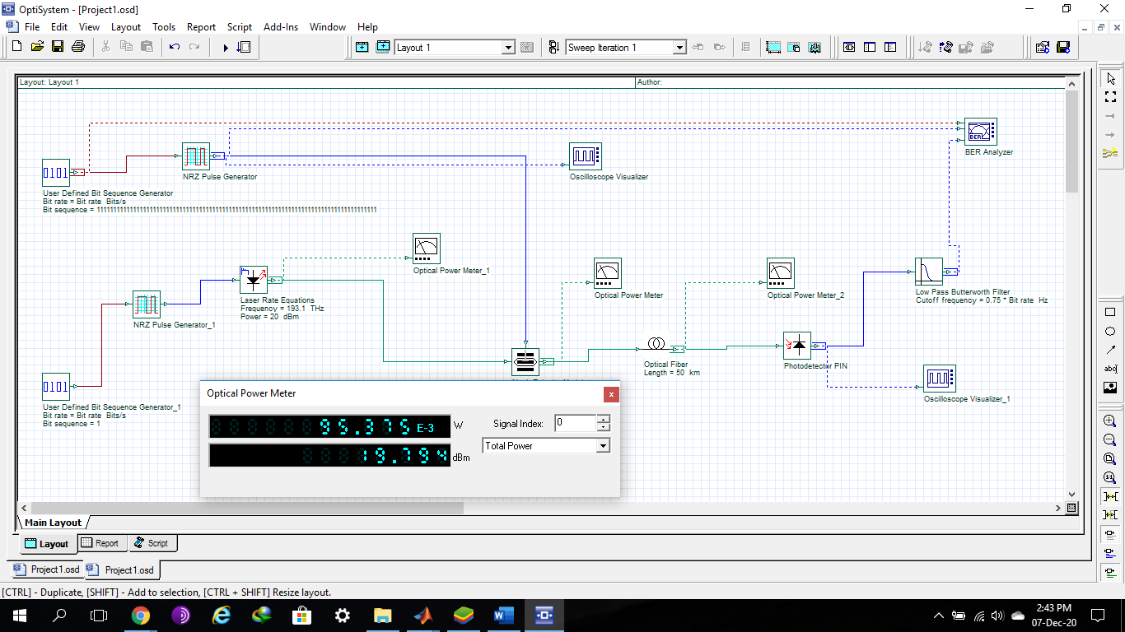

Fig. No. 3

Power Consumption of Laser of Inverted Transmitter is shown in figure number 4.

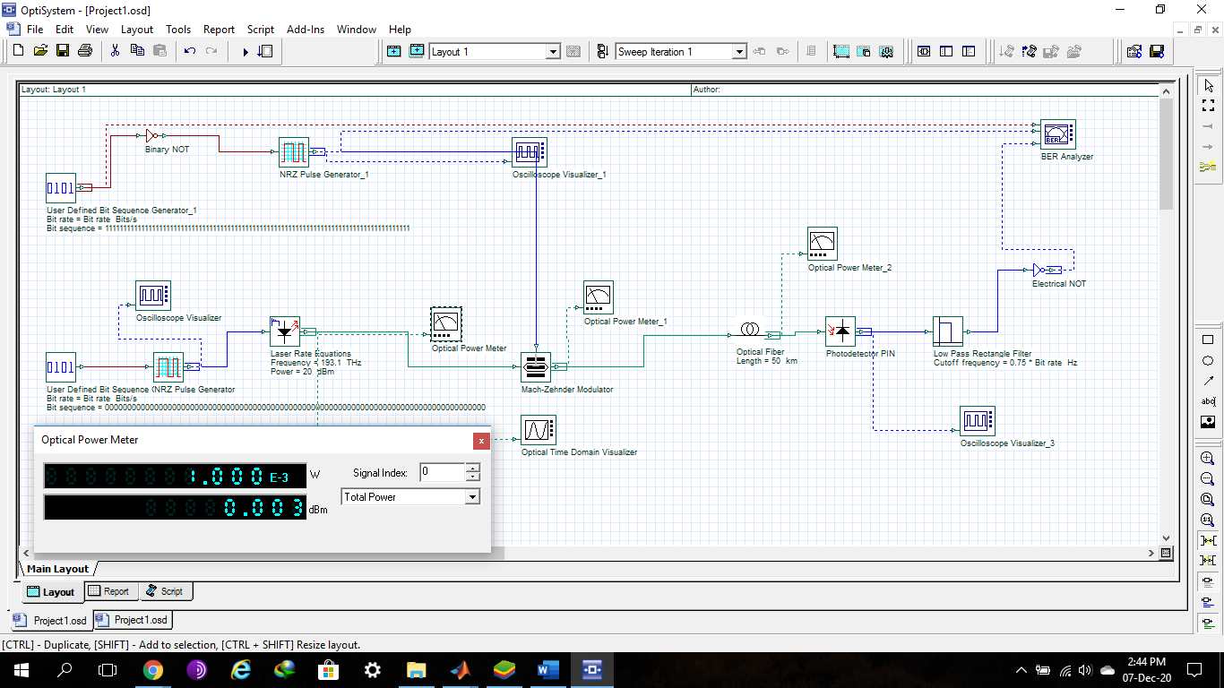

Fig. No. 4

Now we observe here that when we transmit binary stream of 1’s through Direct Transmitter and Inverted Transmitter which consume 95.375x10^-3W power and 1x10^-3W respectively.

Similarly, when we transmit binary stream of 0’s up to 10^6 bits and observe power consumption by both Direct and Inverted Transmitter respectively.

Power Consumption of Direct Transmitter is shown in figure number 5.

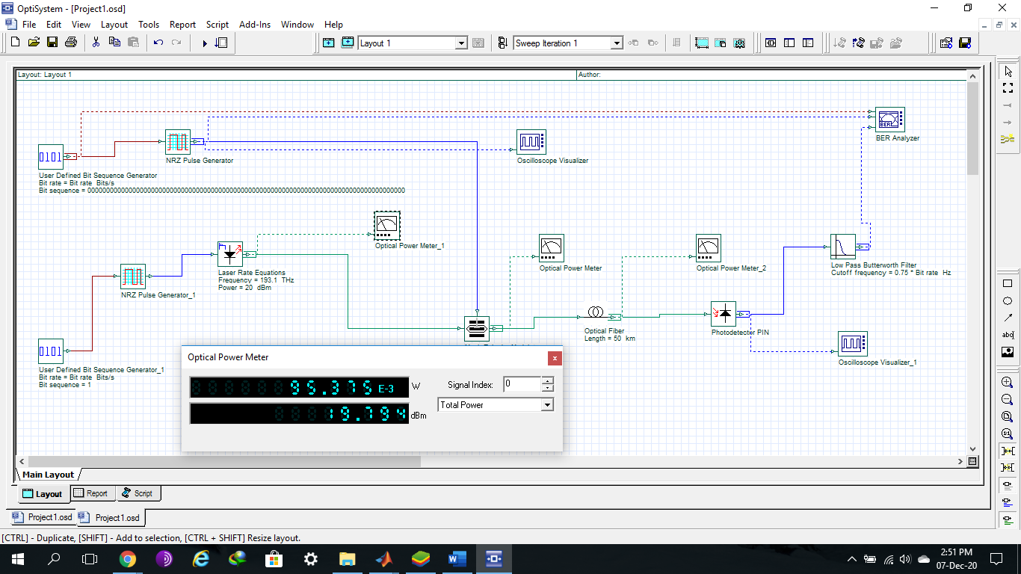

Fig. No. 5

When we transmit binary stream of 0’s through Direct Transmitter, Laser consumes 95.375x10^-3W power which is same as when we transmit 1’s because in Direct Transmitter laser is generating pulse every time of transmission.

Power Consumption of Laser of Inverted Transmitter is shown in figure number 6.

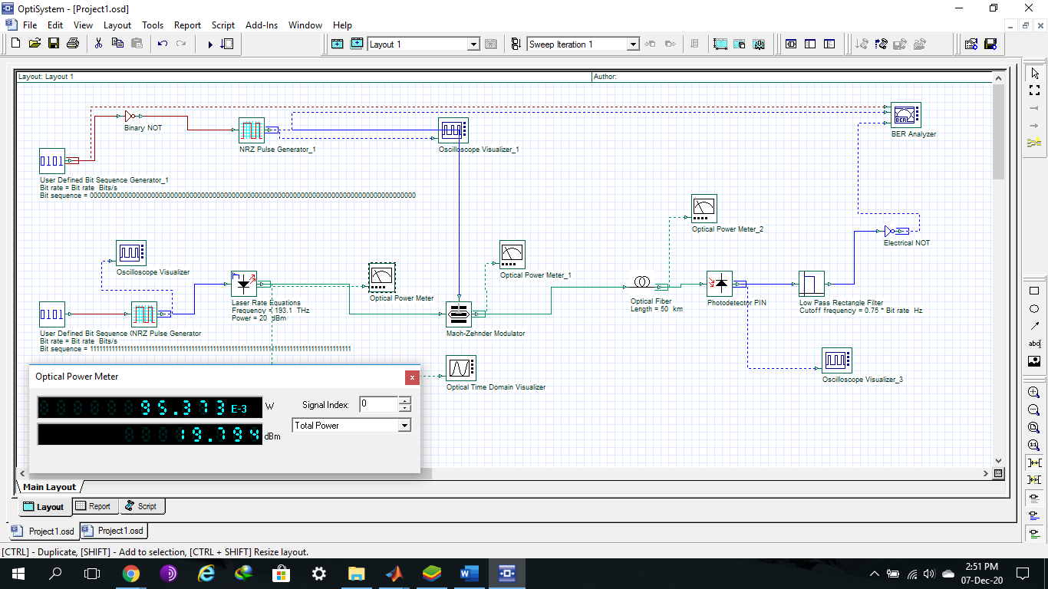

Fig. No. 6

Now, here we observe that when we transmit sequence of 1’s through Direct Transmitter or sequence of 0’s through Inverted Transmitter there is no power reduction because we transmit inverted sequence in Inverted Transmitter. So, in case of 0 bit laser is radiate light and consume power.

To observe power reduction in Transmitter, we transmit a sequence of bits(1110) in which 1 is more than 0 up to 4x10^6 bits and observe power consumption of laser in both **Direct** and **Inverted** **Transmitter** respectively.

Power Consumption Laser of Direct Transmitter is shown in figure number 7.

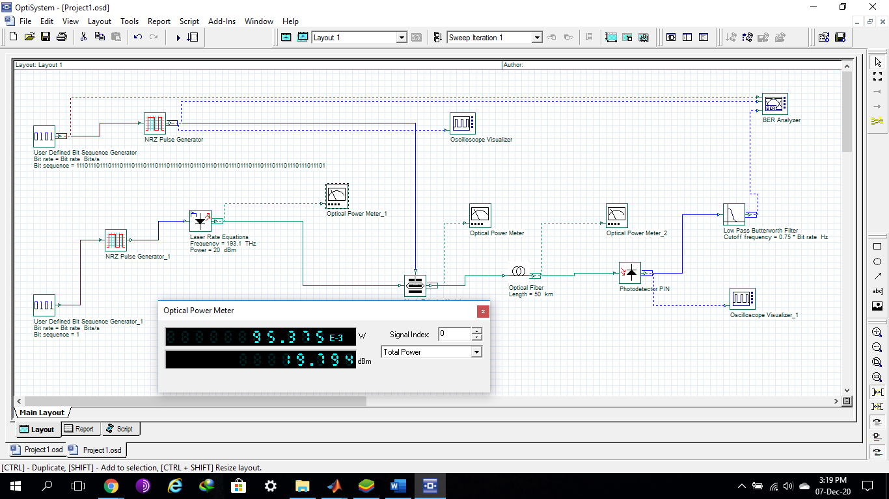

Fig. No. 7

Power Consumption of Laser of Inverted Transmitter is shown in figure number 8.

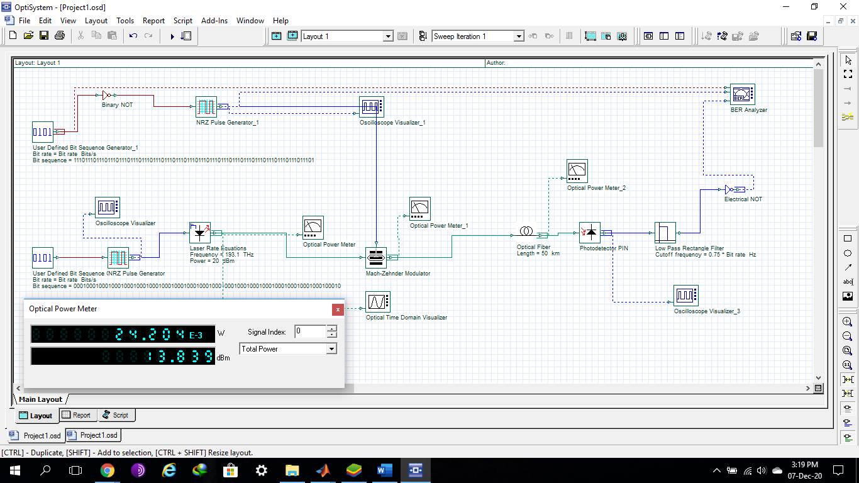

Fig. No. 8

Now observe power consumption of laser of both **Direct** and **Inverted Transmitter** is **95.375x10^-3W** and **24.204x10^-3W**, respectively. So, **power reduction** by **Inverted Transmitter** is **71.171x10^-3W**.

So, in our algorithm, we divide the process into 3 section that is counter, Inverter and Transmitter.

The Counter section count the set bits up to frame size and add a bit at starting of each frame. By default, starting bit is 0. But if the count is more than 50% of frame size, starting bit will be 1.

The Inverter section complements the frame bits, if starting bit of each frame is 1 else directly pass it through the transmitter.

In Transmitter laser is switch according to frame bits, when frame bit is 1 laser is high otherwise low. Transmitter modulate frame bits and transmit each frame serially through optical channel.

At receiver side, to identify that whether a frame is inverted or not we add a starting bit in starting of each frame which is by default 0. If a frame bit is inverted then starting bit of frame is 1.

As we decrease the frame rate, we observe that power consumption of circuit is decrease but increase bits in signal because we add an extra bit in starting of each frame that will increase the time complexity and probability of error in bits. After so many observations, we observed that if we take frame size of 24 bits than power reduction is more and time complexity and probability of error is less in compare of power reduction or mainly, In Optical Communication we work on frequencies greater than GHz which is very large. So, increase in time complexity is negligible for Gbps.